INDEX
1．Safety Precautions and Warnings 3
2. Using the Scan Tool 5
2.1 Tool Description 5
2.2 Specifications 6
2.3 Accessories Include 6
2.4 Product Troubleshooting 7
3. Software Function 9
3.1 System Configuration 10
4. Diagnostics 12
4.1 Read Trouble Code 14
4.2 Erasing Codes 15
4.3 Read Data Stream 16
5．Software update 19

1．Safety Precautions and Warnings
To prevent personal injury or damage to vehicles and/or the scan tool. Read this instruction manual first and observe the following safety precautions at a minimum whenever working on a vehicle.

·Always perform automotive testing in a safe environment.
·Wear safety eye protection that meets ANSI standards.
·Keep clothing, hair, hands, tools, test equipment, etc. Away from all moving or hot engine parts.
·Operate the vehicle in a well ventilated work area: Exhaust gases are poisonous.
·Put blocks in front of the drive wheels and never leave the vehicle unattended while running tests.
·Use extreme caution when working around the ignition coil, distributor cap, ignition wires and spark plugs. Theses components create hazardous voltages when the engine is running.
·NEUTRAL (for manual transmission) and make sure the sparking brake is engaged.
·Keep a fire extinguisher suitable for gasoline/chemical/electrical fires nearby.
·Don’t connect or disconnect any test equipment while the ignition is on or the engine is running.
·Keep the scan tool dry, clean, free from oil/water or grease. Use a mild detergent on a clean cloth to clean the outside of the scan tool, when necessary.

2. Using the Scan Tool

2.1 Tool Description
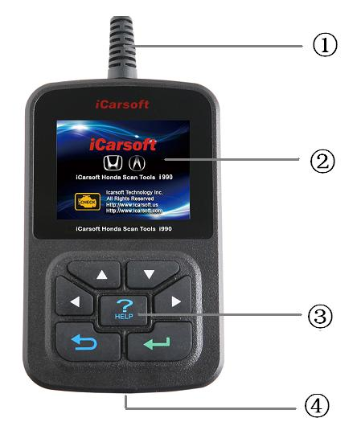
① DLC -- Data Link Connector (DLC), Use to connect the scan tool to the vehicle;
② LCD DISPLAY -- Indicates test results. Color, 320 x 240 pixel display with contrast adjustment
③ KEY BROAD – include [][][][][] [] [HELP]
④ USB PORT -- Use to connect the scan tool to PC;

2.2 Specifications
A) Display: Color, 320 x 240 pixel display with contrast adjustment
B) Operation Temperature: -20 ℃ -- 75 ℃
C) Storage Temperature: -40 ℃ -- 120 ℃
D) Power: 8V -- 24V
E) Dimensions:
Length | Width | Height
135mm | 85mm | 26mm
F) Weight
Net Weight: 250 g
Gross Weight: 450 g

2.3 Accessories Include
A) User’s Manual – Instructions on tool operations.
B) USB Cable – Used to upgrade the scan tool.
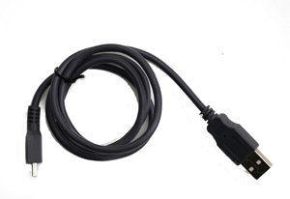
C) CD – save the update tool and user’s manual.

2.4 Product Troubleshooting
Vehicle Linking Error
A communication error occurs if the scan tool fails to communicate with the vehicle’s ECU (Engine Control Unit). You need to do the following to check up:
A) Verify that the ignition is ON;
B) Check if the scan tool’s OBD II connector is securely connected to the vehicle’s DLC;
C) Verify that the vehicle is OBD2 compliant;
D) Turn the ignition off and wait for about 10 seconds. Turn the ignition back to on and continue the testing.
E) Verify the control module is not defective

Scan tool doesn’t power up
If the scan tool won’t power up or operates incorrectly in any other way, you need to do the following to check up:
A) Check if the scan tool’s OBD II connector is securely connected to the vehicle’s DLC;
B) Check if the DLC pins are bent or broken. Clean the DLC pins if necessary.
C) Check vehicle battery to make sure it is still good with at least 8.0 volts.

3. Software Function
CATION: Don’t connect or disconnect any test equipment with ignition on or engine running.
- Turn the ignition off.
- Locate the vehicle’s 16-pin Data Link Connector (DLC)
- Plug into the scan tool cable connector to the vehicle's DLC ，the scan tool will be light. As shown
- Turn the ignition on. Engine can be off or running

- Press any key to enter Main Menu.
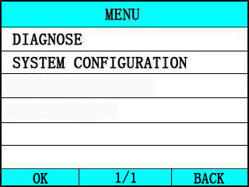
USE the key [][] to select in the [Main Menu] , and press [] to select

3.1 System Configuration
Select [SYSTEM CONFIGUARATION] in the Main Menu and press []. The screen will display the interface as shown below:
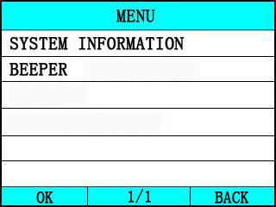
The scanner allows you to make the following adjustment settings;
1) [SYSTEM INFORMATION]: show the system information
Choose [SYSTEM INFORMATION] and press [].
The screen will display the interface as shown below:
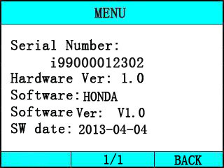
Press [] or [] to return the [Main menu]
2) [BEEPER]: ON / OFF the beep.
Choose [BEEPER] and press [], the screen will display the interface as shown below:
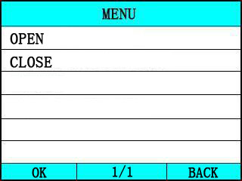
Press [][] to select, and press [] to confirm.

4. Diagnostics
Select [DIAGNOSE] in Main Menu and press [].
The scanner will communicate with the vehicle , if the scanner can not communicate with the vehicle , it will display the error message, as shown below:
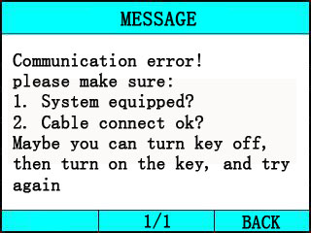

If the scanner can communicate with the vehicle , it will display the system menu, as shown below:
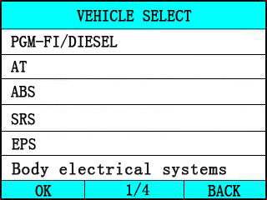
Select one system and press[], the scanner will communicate with the system .
◆ if the scanner communication fail with the vehicle’s ECU, a “ERROR” message shows up on the display
- if the scanner communicates successfully with the vehicle, it will display system ID, as shown below:
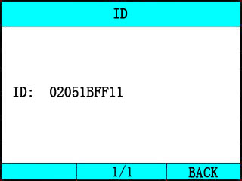

Press [] and enter the function menu , as shown below:
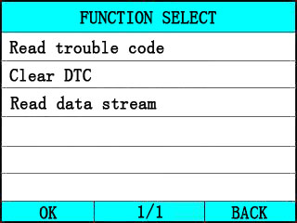
Press [][] to select, [] and [] to Page, and press [] to confirm.

4.1 Read Trouble Code
◆Reading Codes can be done with the key on engine off (KOEO) or with the key on engine running (KOER).
◆Trouble codes cause the control module to illuminate the malfunction indicator lamp (MIL) when emission-related fault occurs.

select [Read Trouble Code] and press [] in [Diagnostic Menu]. If there are some codes, the screen will display the codes as show below:
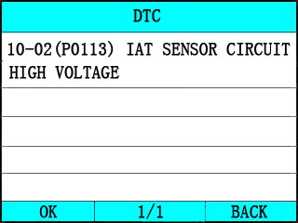
Press [] or [] to return the [Diagnostic menu]

View DTCs and their definitions on screen.
􀁺 If there are no Diagnostic Trouble Codes present, the display indicates “No Trouble Code” Wait a few seconds or press any OK to return to Diagnostic Menu.
􀁺 The control module number, sequence of the DTCs, total number of codes detected and type of codes (Generic or Manufacturer specific) will be observed on the upper right hand corner of the display.

4.2 Erasing Codes
CAUTION: Erasing the Diagnostic Trouble Codes may allow the scan tool to delete not only the codes from the vehicle’s on-board computer,
- This function is performed with key on engine off (KOEO). Do not start the engine.

Select [Erase Trouble Code] and press[] in [Diagnostic Menu]. the screen will display the interface as shown below:
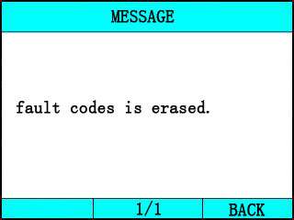
Press [] or [] to return the [Diagnostic menu]

Notes:
* Before performing this function. Make sure to retrieve and record the trouble codes.
* After clearing, you should retrieve trouble codes once more or turn ignition on and retrieve codes again. If there are still some trouble codes for hard troubles, please find the reason caused the trouble code first, and then solve the problem. Now, the trouble codes can be erased.

4.3 Read Data Stream
The Read DataStream function allows viewing of live or real time data of vehicle’s computer module(s). This function is not supported for some system.
Press[][] to select [Read DataStream] in [Diagnostic Menu] and press [] to confirm. The screen will display the interface as shown below.

Data model

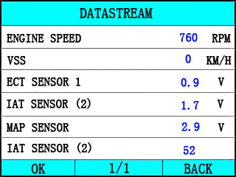

If appear [GRAPH], Press [] to enter Graph mode.
Press [] to return [Diagnostic Menu]
the screen will display the interface as below:
Graph model

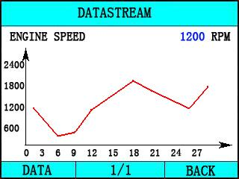

Press [] to return data model. Press [] to return [DIAGNOSTIC MENU].

5．Software update
1. Setup Update tools
Put the CD in to PC and open. You can see the setup file in the CD.
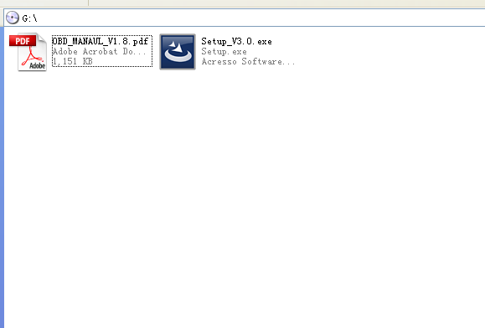

Double click the [Setup file] to setup the tool.
Operate following the instructions, and finish to setup.
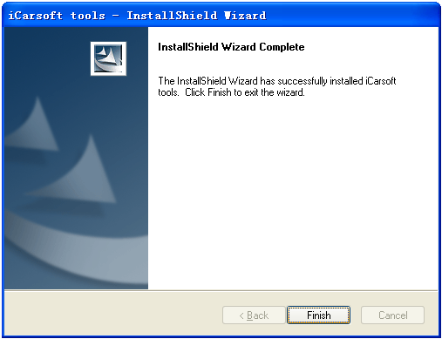
After finish setup , there is an icon of scanner in desktop.

2. Run the update tool and Operate in accordance with photographs
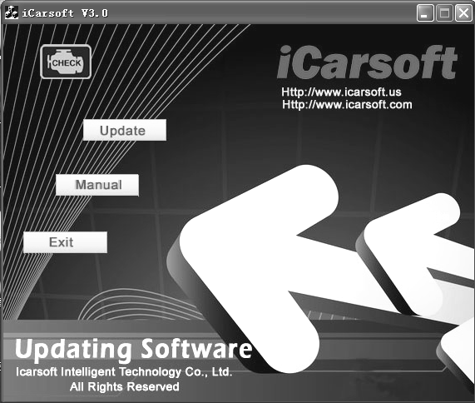
a) Use the USB cable to connect i910 scanner with PC
b) Run the update software.

When the scanner connect with PC , the software will show [USB CONNECTED], As below:
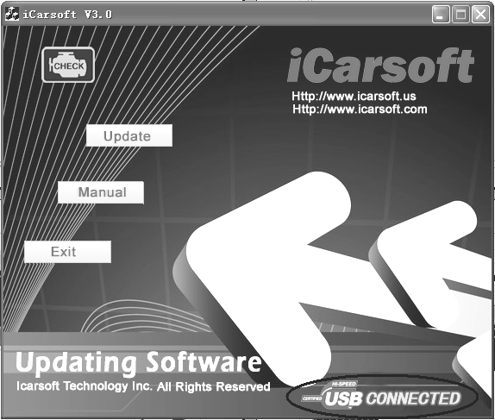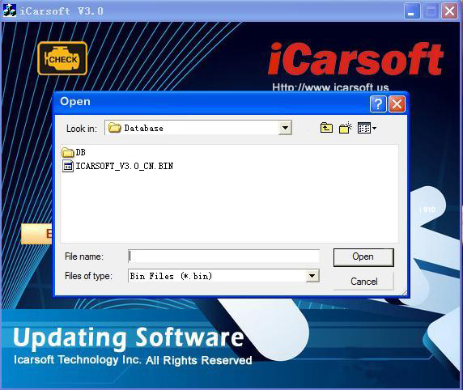
- Click [Update] button.
- Click [] to find the update file
- Select update file and click [open] button.
- Into the upgrade interface, wait for the end of upgrade

WARNNING:
Do not power off during upgrade!
Do not Plug or Unplug USB tools during upgrade!
Start Update
Waiting for a few minutes. The software will update the scanner tool.
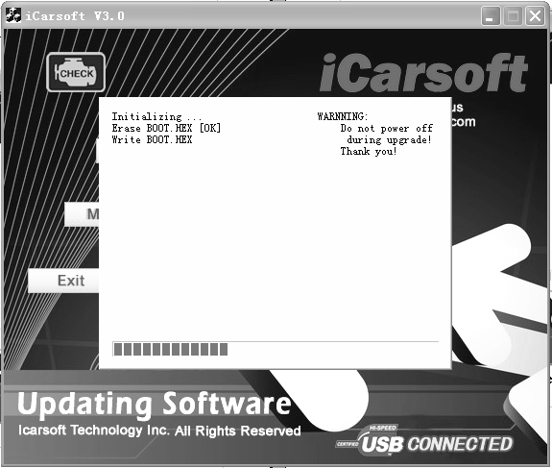

Finish Update
When the update is finished, the screen on PC will show as below.
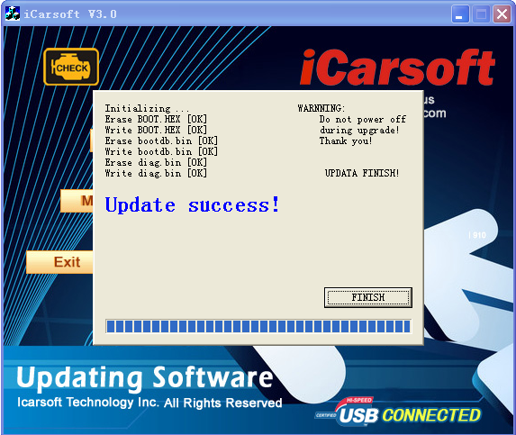
If update success, the software will display [Update success!]; if update not success, it will display [Update fail! Try again].
Press [finish] , the scanner is already updated ,and you can unplug the scanner from PC.

